# Final Year Project Weekly Assignment 1

Name: Pranaya Pradhan

Group: C4

Internal Supervisor: Rohit Pandey

External Supervisor: Shekhar Timisina

# Detailed Feature List

## For Website (Admin/Editor)

* **Adds Editor**
* News Feeds
* News Title
* News Description
* News Image
* Actions:
  + Add the News
  + Update the News
  + Delete the News (if required)
* Club Detail
* Club Name
* Club Description
* Club Logo
* Club Address
* Club Email
* Club Telephone
* Club Affiliation
* Actions:

- Adds the Club details

- Update/Edit the Club details

- Delete the Club detail (if required)

* Player Detail
* Player Name
* Date of Birth
* Place of Birth
* Position
* Jersey No
* Nationality
* Image
* Club Id
* Status (activate/deactivate)
* Actions:
  + Adds the Player details
  + Update/Edit the Players details
  + Delete the Player details (if required)

* Fixtures
* Club 1
* Club 2
* Date
* Time
* Venue
* Result
* Actions:
* Adds the match/fixtures detail
* Edit/Update the fixture detail
* Delete the fixture detail
* Statistics
* Highest Scorer
  + Id
  + Player Name
  + Club
  + Total Goals
* Red Card
  + Id
  + Player Name
  + Club
  + Total Cards
* Yellow Card
  + Id
  + Player Name
  + Club
  + Total Cards
* Actions:
* Adds the Statistics detail
* Edit/Update the Statistics Detail
* Delete the Statistics Detail

## For Mobile App (User)

* News Feeds
* News Title
* News Description
* News Image
* Actions:
  + Views the news feeds
* Club Detail
* Club Name
* Club Description
* Club Logo
* Club Address
* Club Email
* Club Telephone
* Club Affiliation
* Actions:

- Views the Club Detail

* Player Detail
* Player Name
* Date of Birth
* Place of Birth
* Position
* Jersey No
* Nationality
* Image
* Club Id
* Status (activate/deactivate)
* Actions:
  + Views the Player Detail

* Fixtures
* Club 1
* Club 2
* Date
* Time
* Venue
* Result
* Actions:
* Views the Fixtures
* Statistics
* Highest Scorer
  + Id
  + Player Name
  + Club
  + Total Goals
* Red Card
  + Id
  + Player Name
  + Club
  + Total Cards
* Yellow Card
  + Id
  + Player Name
  + Club
  + Total Cards
* Actions:
* Views the Statistics

# Wire Frame of each feature

## For Website (Admin/Editor)

### Login

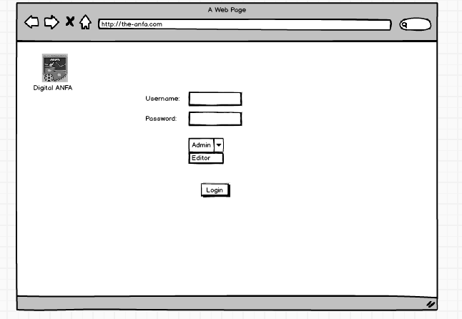

Figure Web Login

### News Feed

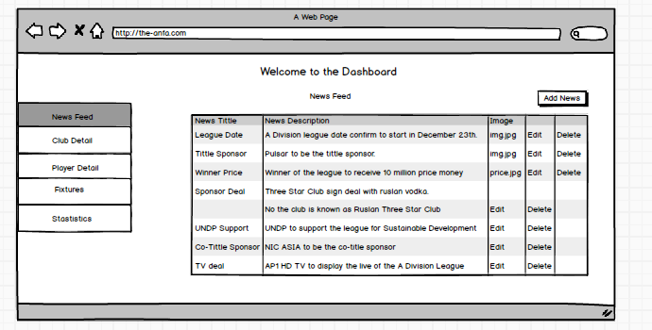

Figure News Feed

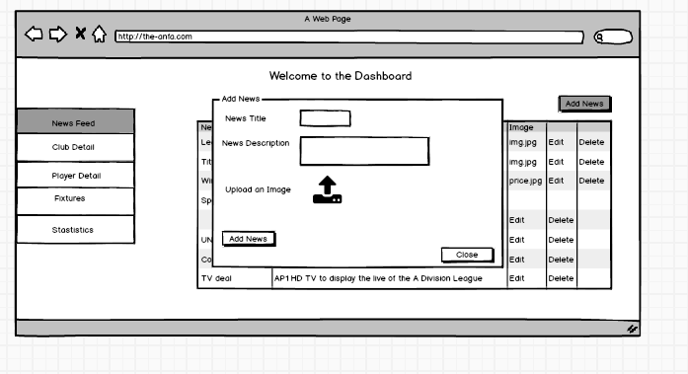

Figure Add Action of News Feed Table

### Club Detail

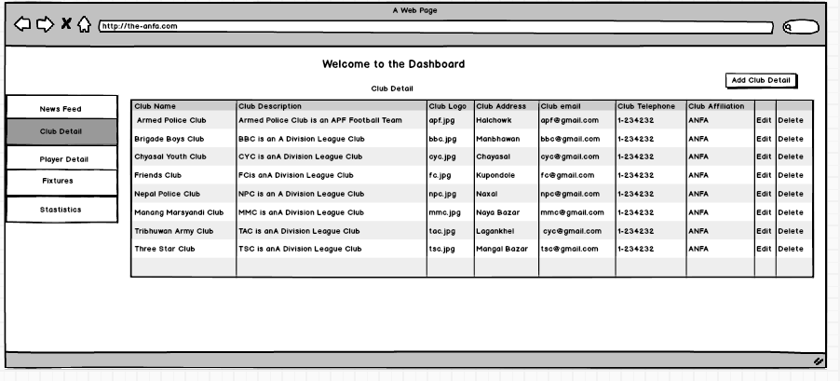

Figure Club Detail Table

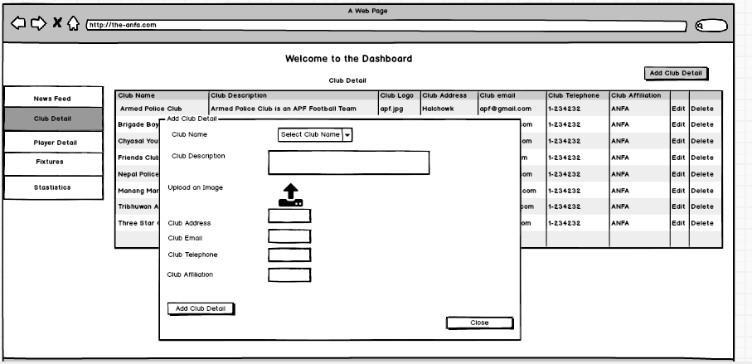

Figure Action to Add Club Detail

### Player Detail

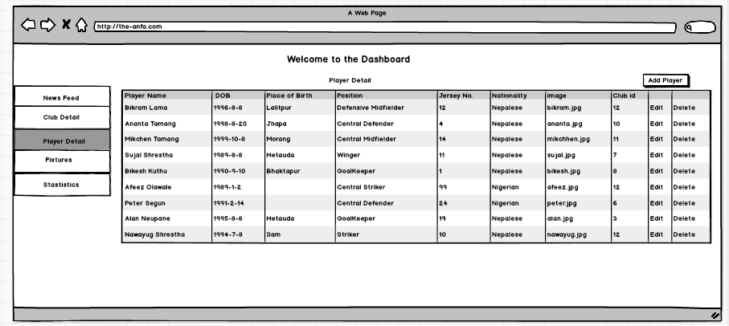

Figure Player Detail Table

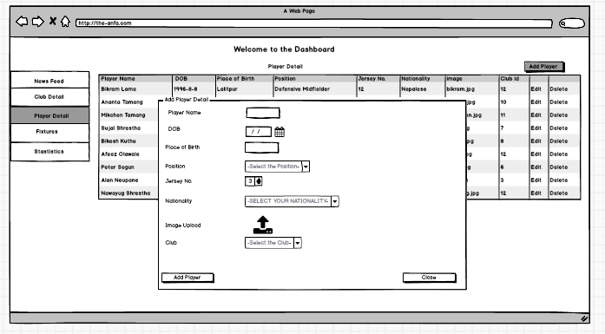

Figure Action of Player Detail Table

### Fixtures

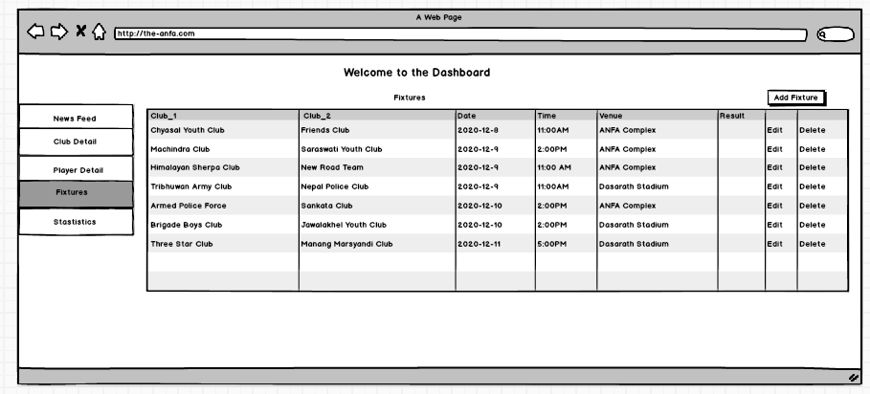

Figure Fixture Table

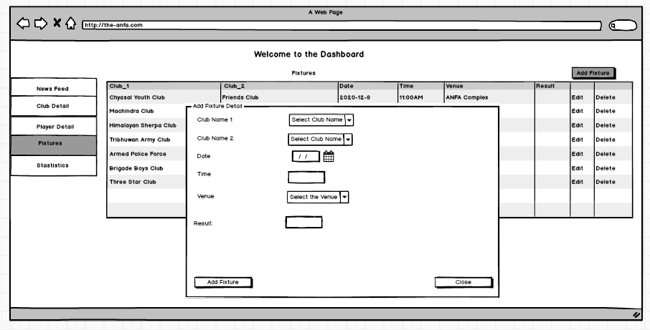

Figure Action to add in Fixtures Table

### Statistics

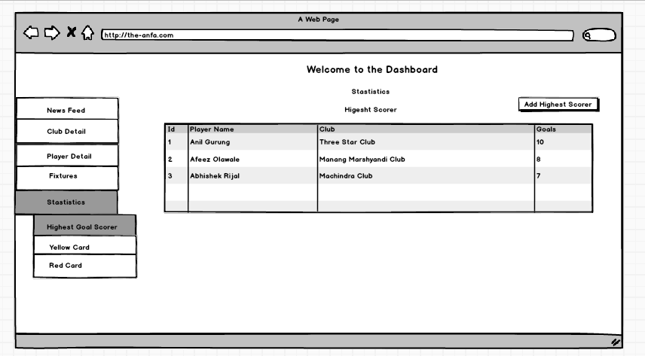

Figure Statistics Table of Highest Scorer

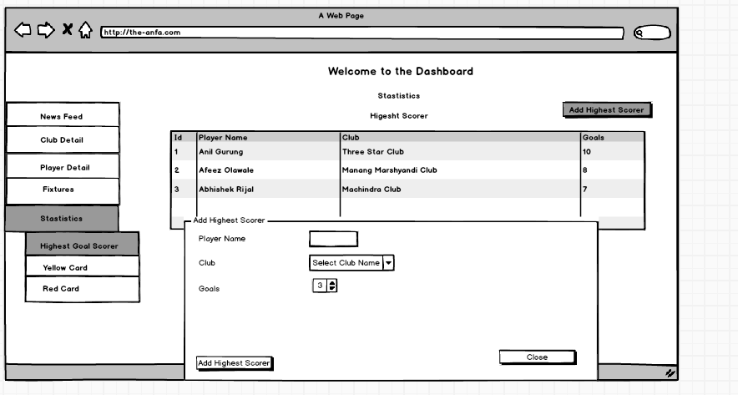

Figure Action to add Highest Scorer

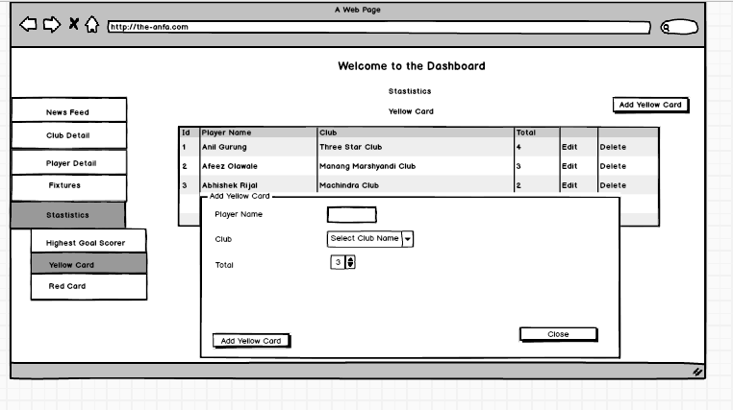

Figure Statistics Table for Yellow Card

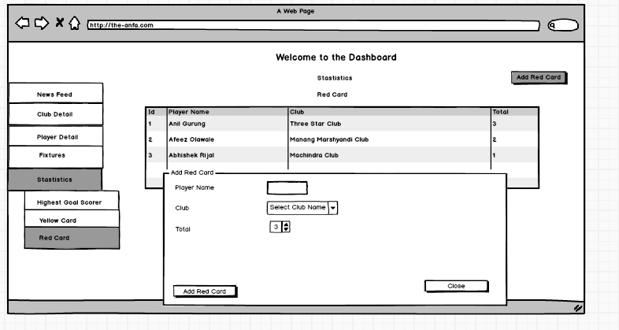

Figure Add Action for Yellow Card



Figure Statistics for Red Card

## For Mobile Application (User)

### Splash Screen

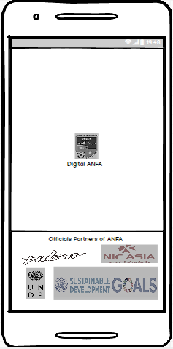

Figure Splash Screen

### News Feed Screen

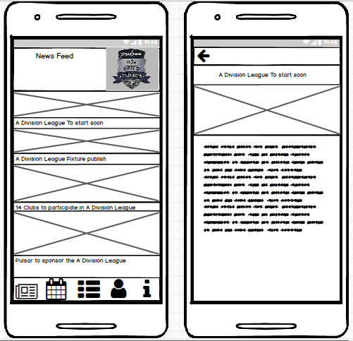

Figure News Feed Screen

### Fixtures Screen

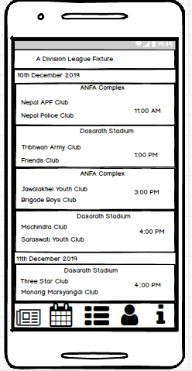

Figure Fixture Screen

### Statistics Screen

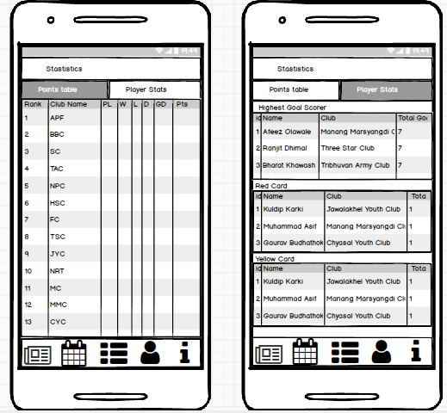

Figure Statistics

### Club Profile Screen

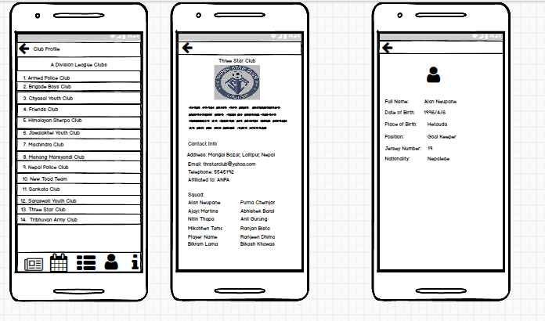

Figure Club Profile

### About Us Screen

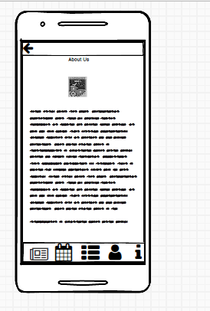

Figure About Us Screen

# UML Diagram

## Use Case



Figure Overall Use Case Diagram

## High Level Description

### Access into Dashboard

|  |  |
| --- | --- |
| Use Case: | Access to dashboard |
| Actors: | Admin, Editor |
| Description: | An Actors logs in and get access to the dashboard. |

### Adds the Editor

|  |  |
| --- | --- |
| Use Case: | Adds the editor |
| Actors: | Admin |
| Description: | An Actor adds the editor. |

### Keeps News in Feed

|  |  |
| --- | --- |
| Use Case: | Keeps News in Feed |
| Actors: | Admin, Editor |
| Description: | The actors adds news in the news feed section. |

### Upload Clubs and Players Detail

|  |  |
| --- | --- |
| Use Case: | Upload Clubs and Players Detail |
| Actors: | Admin, Editor |
| Description: | The actors uploads the clubs and player details. |

### Records the Statistics

|  |  |
| --- | --- |
| Use Case: | Record the Statistics |
| Actors: | Admin, Editor |
| Description: | The actors records the statistics of the games. |

### Update the Fixtures

|  |  |
| --- | --- |
| Use Case: | Update the Fixtures |
| Actors: | Admin, Editor |
| Description: | The actors updates the fixtures of the match |

### Reads the news

|  |  |
| --- | --- |
| Use Case: | Reads the news |
| Actors: | User |
| Description: | The user reads the news about the tournament. |

### Get Club Detail

|  |  |
| --- | --- |
| Use Case: | Get Club Detail |
| Actors: | User |
| Description: | The user get the information of the Football Club. |

### Gets Player Detail

|  |  |
| --- | --- |
| Use Case: | Gets Player Detail |
| Actors: | User |
| Description: | The user gets brief detail of the players. |

### Views Statistics

|  |  |
| --- | --- |
| Use Case: | Views the Statistics |
| Actors: | User |
| Description: | An user views the statistics of the tournament. |

### Knows the fixtures

|  |  |
| --- | --- |
| Use Case: | Knows the fixtures |
| Actors: | User |
| Description: | An user get information about the fixtures. |

### For Web(Admin/Editor)

### Use Case of News Feed

|  |  |
| --- | --- |
| Name: | Keep News in Feed |
| Actors: | Editor, Admin |
| Description: | The actors keep the news in the news feed section. He/she can add, edit and delete the news. |



Figure Add News



Figure Edit News

Figure Delete the News

### Use Case of Fixtures

|  |  |
| --- | --- |
| Name: | Update the fixtures |
| Actors: | Editor, Admin |
| Description: | The actors have permission to update the fixture of the matches. |



Figure Add Fixtures



Figure Edit the fixtures



Figure Delete the Fixture

### Use Case of Club Detail

|  |  |
| --- | --- |
| Name: | Upload Club and Player Detail |
| Actors: | Editor, Admin |
| Description: | The actors have right to upload the club detail. Similarly, he/she can edit as well delete the detail if require. |



Figure Add Club Detail



Figure Edit Club Detail



Figure Delete Club Detail

### Use Case of Player Detail

|  |  |
| --- | --- |
| Name: | Upload Club and Player Detail |
| Actors: | Editor, Admin |
| Description: | The actors have right to upload the player detail. Similarly, he/she can edit as well delete the detail if require. |

Figure Use Case of Add Player Detail



Figure Use Case of Edit Player Detail

Figure Delete Player Detail

### Use Case of Statistics

|  |  |
| --- | --- |
| Name: | Upload Club and Player Detail |
| Actors: | Editor, Admin |
| Description: | The actors have an ability to record the statistics of the matches. |



Figure Add Statistics



Figure Edit Statistics



Figure Delete Statistics

### For Mobile (User)

### 3.2.6. Use Case of News Feed

|  |  |
| --- | --- |
| Name: | Reads the News in Feed |
| Actors: | User |
| Description: | The actors view the news tittle and images as well as can read the news. |



Figure Use Case of News Feed

### 3.2.7. Use Case of Fixtures

|  |  |
| --- | --- |
| Name: | Knows the Fixtures |
| Actors: | User |
| Description: | The actors can know the fixture of the match of tournament. |



Figure Use Case of Fixtures

### 3.2.8. Use Case of Statistics

|  |  |
| --- | --- |
| Name: | Views Statistics |
| Actors: | User |
| Description: | The actors have right to statistics of the match. |



Figure Use Case of Statistics

### 3.2.9. Use Case of Club Profile

|  |  |
| --- | --- |
| Name: | Gets Club and Player Detail |
| Actors: | User |
| Description: | The actors gets the detail of the clubs and players. |

Figure Use Case of Club Profile